ATM MANAGEMENT SYSTEM
A Course Work Project Report submitted in partial fulfillment of the requirement
for the award of the degree of
Bachelor of Technology
in
Computer Science & Engineering (AI&ML)
By
2103A52006 B.Harini Sri
2103A52007 B.Anvithaa
2103A52023 M.Vyshnavi

Under the guidance of
Mr. Radhakrishnan P,
Assistant Professor
School of CS & AI



DEPARTMENT OF COMPUTER SCIENCE & ARTIFICIAL INTELLEGENCE
Ananthasagar village, Hasanparthy Mandal, Hanmakonda District – 500 376
(2022 - 2023)

ACKNOWLEDGEMENTS

First and foremost, we express our sincere thanks for the guidance and encouragement rendered by Mr.Radhakrishnan P, Assistant Professor in the Department of Computer Science & Artificial Intellegence, SR University, Ananthasagar, Hanmakonda District. We extend our gratitude for his advice and guidance during the progress of this course project.
Secondly, We express our sincere thanks to Dr. M. Shashikala, Associate Professor & Head, Department of CS & AI, SR University who stood as silent inspiration behind this course project. Our heartfelt thanks for her endorsement and valuable suggestions.
We wish to express our profound thanks to Dr. C. V. Guru Rao, Registrar & Dean, School of CS & AI for providing necessary facilities to make this course project a success.
We thank all the members of teaching and non-teaching staff members, and also who have assisted us directly or indirectly for successful completion of this course project.
Finally, We would like to express our sincere gratitude to our parents who are constantly encouraging us through-out our lives and for completion of this course project.

2103A52006 (B.Harini Sri)
2103A52007 (B.Anvitha)
2103A52023 (M.Vyshnavi)

DECLARATION

We declare that the course project work entitled “ATM MANAGEMENT SYSTEM”recorded in this course project work does not form part of any other project work. We further declare that the course project work report is based on our work carried-out at “SR University, Ananthasagar Mandal, Hanmakonda District – 506 371” in the second year of our B.Tech course.

2103A52006 - B.Harini Sri
2103A52007 - B.Anvitha
2103A52023 - M.Vyshnavi

Date:08-12-2022 Place: SR University

Ananthasagar, Hasanparthy Mandal, Warangal District – 506 371. www.sru.edu.in

CERTIFICATE

This is to certify that the course project report entitled ATM MANAGEMENT SYSYTEM that is being submitted by 2103A52006(B.HariniSri),2103A52007(B.Anvitha),2103A52023 (M.Vyshnavi) in partial fulfillment for the award of B.Tech in Computer Science & Engineering (AI&ML) to the SR University, Ananthasagar, Hanmakonda-506371 is a record of bonafide work carried out by them under my guidance and supervision.

Supervisor Head
Mr.Radhakrishnan P Department of CS & AI
Dr.M.Shashikala

ABSTRACT

This project is about ATM management system by using Data Structures.
The ATM System is the project which is used to access their bank accounts in order to make cash with drawals.Whenever user want to make withdrawals, they can enter their ATM card and verified PIN ,then user select the with drawal option and enter the withdrawal amounts and it will display the amount to be withdrawn in the form of50's,100's and 500's.
This system will provide for secure connections between users and the bank servers. The whole process will be automated right from PIN validation to transaction completion. The card details and PIN database will be asecure module that will not be open to routine maintenance, the only possibility of access to this database will be through queries(questions) raised from an ATM in the presence of a valid bank ATM card.
ATM Simulation System will enable two important features of an ATM,reduction of human error in the banking system and the possibility of 24 hour personal banking.

CONTENTS

- Introduction 1 - 6
  - Problem Statement 2
  - System Design & Modules 3
  - Module Details 4
  - Software Specifications 5
- Coding 7 - 9
- Outputs 10 – 13
- Conclusion 14

1.INTRODUCTION

ATM, when he enters the necessary option and arguments. The product also provides services like request for cheque .Automated Teller Machine enables the clients of a bank to have access to their account without going to the bank. This is achieved only by development the application using online concepts.
When the product is implemented, the user who uses this product will be able to see all the information and services provided by the s, deposit cash and other advanced requirement of the user. The data is stored in the database and is retrieved whenever necessary. The implementation needs ATM machine hardware to operate or similar simulated conditions can also be used to successfully use the developed product.
To develop this ATM system the entire operation has been divided into the following step:
verification process
language, service and account selection
Banking services
Transactions
Special services
The program is designed in such a way that the user has to card and pin number. Once verified, he is provided a menu and he/she had to enter the option provided in the menu. For example, when the user wants to view the list of payment history than he/she had to enter the option for payment history provided in the main menu. When the option is entered alone with the respective argument, then the payment history is displayed on the screen.
The user also must be given option to browse through the pages like previous page, next page, etc. The user may experience a delay in retrieving or viewing the data, when there are many users logged on to the same bank branch system
The user also able to perform one or more transactions. Security is the foundation of good ATM system. ATMs are omnipresent these days, at least in major cities and towns. It is an empowering technology, as one can withdraw or transfer money any time they want. Now the enrolment for bank accounts is on the rise, which will include many illiterate or old people also. Is the current ATM experience good enough for them to use it?
The project entitled ATM system has a drastic change to that of the older version of banking system, customer feel inconvenient with the transaction method as it was in the hands of the bank employees .In our ATM system, the above problem is overcome here, the transactions are done in person by the customer thus makes the customers feel safe and secure. Thus the application of our system helps the customer in checking the balance and transaction of the amount by validating the pin number therefore ATM system is more user friendly..

1.1PROBLEM STATEMENT:

The user also able to perform one or more transactions. Security is the foundation of good ATM system. ATMs are omnipresent these days, at least in major cities and towns. It is an empowering technology, as one can withdraw or transfer money any time they want. Now the enrolment for bank accounts is on the rise, which will include many illiterate or old people also. Is the current ATM experience good enough for them to use it?
The project entitled ATM system has a drastic change to that of the older version of banking system, customer feel inconvenient with the transaction method as it was in the hands of the bank employees .In our ATM system, the above problem is overcome here, the transactions are done in person by the customer thus makes the customers feel safe and secure. Thus the application of our system helps the customer in checking the balance and transaction of the amount by validating the pin number therefore ATM system is more user friendly.

1.2 SYSTEM DESIGN AND MODULE:

Features:

1.Implemented queues using linked lists to hold the history of latest 10 transactions.

2.Randomly generating PIN numbers for ATM access.

3.Using File I/O to store PIN numbers.

4.Search for PIN in the file to validate PIN entered by User.

Concepts used:
- Queue data structure
- File operations
- Structures
- Pointers
- Dynamic Memory Allocation

1.3 Module Details:

1.Queue data structure:
A queue is defined as a linear data structure that is open at both ends and the operations are performed in First In First Out (FIFO) order. We define a queue to be a list in which all additions to the list are made at one end, and all deletions from the list are made at the other end.
2.Structures:
A file is an abstract data type. To define a file properly, we need to consider the operation that can be performed on files. Six basic file operations. The OS can provide system calls to create, write, read, reposition, delete, and truncate files.
3.Pointers:
Pointers in C are used to store the address of variables or a memory location. This variable can be of any data type i.e, int, char, function, array, or any other pointer. The size of the pointer depends on the architecture.
4.Dynamic Memory Allocation:
In the C programming language, the random function has two inbuilt functions: rand() and srand() function. The rand() function returns the random integers whose range from 0 to RAND_MAX. The RAND_MAX is a symbolic constant that defines in stdlib.h header file, whose value is greater but less than 32767 depending on the C libraries.
1.4 Software Specifications:
Software & Hardware Specifications:

Operating system : Windows 11 Home Edition Application Software : Dev C++, Version 5.11
Processor : Intel Core i5,11th Generation
RAM : 8GB DDR4
SSD : 512 gb,2000RPM

Dev C++ Editor:
Dev C++ is a complete IDE for the C++ language.
The IDE uses a MinGW port of GCC (GNU Compiler Collection) as its compiler. MinGW is a minimalist approach to write executables for Windows systems. Dev C++ is also usable with Cygwin or any other GCC-based compiler. It was first built in Delphi and was upgraded using Delphi’s latest version.
Millions of users have used Dev C++since the first version was released back in 1998 by Bloodshed Software. Having been around for over 20 years, the IDE remains a popular learning tool for universities worldwide.
Bloodshed abandoned Dev C++ in 2006 when the team no longer had the time
to support it. The software was picked back up in 2010 by Johan Mes, an independent programmer who goes by the name Orwell. After 10 years of working on the IDE, Orwell stepped away from the project. U.S. software company, Embarcadero Technologies, subsequently began sponsoring the IDE and now maintains it.

Windows 11:

Windows 11 is the latest major release of Microsoft's Windows NT operating system, released in October 2021. It is a free upgrade to its predecessor, Windows 10 (2015),
available for any Windows 10 devices that meet the new Windows 11 system requirements.
Windows 11 features major changes to the Windows shell influenced by the canceled
Windows 10X, including a redesigned Start menu, the replacement of its "live tiles “with a separate "Widgets" panel on the taskbar, the ability to create tiled sets of windows that can be minimized and restored from the taskbar as a group, and new gaming technologies inherited from Xbox Series X and Series S such as Auto HDR and Direct Storage on compatible hardware. Internet Explorer (IE) has been replaced by the Chromium-based Microsoft Edge as the default web browser like its predecessor, Windows 10, and Microsoft Teams is integrated into the Windows shell. Microsoft also announced plans to allow more flexibility in software that can be distributed via Microsoft Store, and to support Android apps on Windows 11 (including a partnership with Amazon to make its app store available for the function).
Windows11 has received a mixed reception. Pre-release coverage of the operating system focused on its stricter hardware requirements, with discussions over whether they were legitimately intended to improve the security of Windows or as a ploy to up sell users to newer devices, and over e-waste associated with the changes.

FLOWCHART:
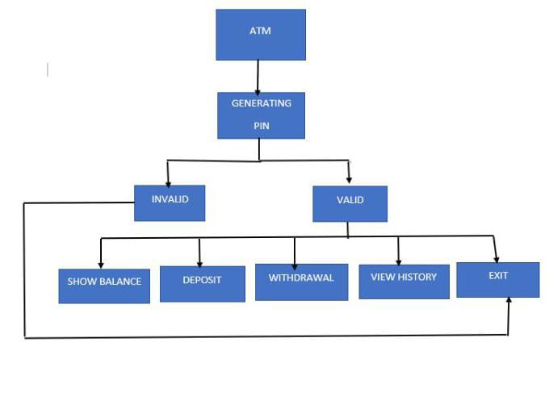

2.CODING
#include<stdio.h>
#include<stdlib.h>
#include<string.h>
#include<time.h>

/*
node structure for implementing a queue to store transaction history
*/
typedef struct node {
char statement[50];
struct node* link;
} node;

/*
ATM function prototypes
*/
void pinGeneration(void);
int checkPin(void);
void showBalance(int *);
void depositMoney(node **, int *);
void withdrawMoney(node **, int *);
void saveHistory(node **, char *);
void removeHistory(node **);
void showHistory(node **);
int main(void) {
int choice1, choice2;
int pinValid = 0, balance = 0;
node *head = NULL;
while (1) {
printf("\n\nATM System\n======================\n");
printf("1. Generate PIN\n2. Use ATM\n3. Exit\n");
printf("\nYour choice: ");
scanf("%d", &choice1);

switch (choice1) {
case 1: pinGeneration();
exit(EXIT_SUCCESS);
case 2: pinValid = checkPin();
if (pinValid) {
printf("\nValid PIN\n");
} else {
printf("\nInvalid PIN. Please generate a PIN if you don't have one.\n");
exit(EXIT_FAILURE);
}

/*
On valid PIN entry by user, the ATM Menu is presented to the user
*/
while(pinValid) {
printf("\nATM System Menu\n===============\n\n");
printf("1. Check Balance\n2. Deposit\n3. Withdraw\n4. View transaction history\n5. Quit\n\n");

printf("Enter choice: ");
scanf("%d", &choice2);

switch(choice2) {
case 1: showBalance(&balance);
break;
case 2: depositMoney(&head, &balance);
break;
case 3: withdrawMoney(&head, &balance);
break;
case 4: showHistory(&head);
break;
case 5: printf("\nThank you for using the ATM\n");
exit(EXIT_SUCCESS);
default: printf("\nInvalid option entered!\n");
break;
}
}
case 3: exit(EXIT_SUCCESS);
default: printf("\nInvalid choice...Try again...\n");
break;
}
}
return 0;
}
/*
This function will search for the PIN entered by the user
In the file where the PIN numbers are stored
If PIN is found return 1
Otherwise, return 0
*/
int checkPin(void) {
FILE *fp;
// buffer to read PIN and store from file
char pin[8];
// buffer to read PIN and store from user
char keyPin[8];
int pinValid = 0;

printf("\n\nEnter the PIN: \n");
scanf("%s", keyPin);

fp = fopen("pin.txt", "r");
if (NULL == fp) {
printf("\nFile cannot be opened\n");
exit(EXIT_FAILURE);
}

/*
Search for the PIN entered by user in file pin.txt
*/
while (fgets(pin, sizeof(pin), fp) != NULL) {
if (strstr(pin, keyPin)) {
pinValid = 1;
}
}
fclose(fp);

return pinValid;
}

/*
This function will generate a 4-digit random number that
is considered as PIN
*/
void pinGeneration(void) {
FILE *fp;

/*
Generate a random 4 digit number
*/
srand(time(NULL));
int generatedPin = 1000+rand()%9000;

printf("\nPIN generated successfully\n");
printf("\nYour generated PIN: %d\n", generatedPin);
printf("\nRe-run the program and use ATM with this PIN\n\n");

fp = fopen("pin.txt", "a");
if (NULL == fp) {
printf("\nCannot open file!");
exit(EXIT_FAILURE);
}

/*
Write PIN to the file
*/
fprintf(fp, "%d\n", generatedPin);
fclose(fp);
}

/*
This function will display the current balance amount
*/
void showBalance(int *balance) {
printf("\nYour current balance is Rs.%d\n", *balance);
}

/*
This function will add the money deposited to the balance
*/
void depositMoney(node **head, int *balance) {
int depositAmount;
/*
buffer to store
*/
char depositStmt[50];

printf("\nEnter amount to deposit: ");
scanf("%d", &depositAmount);

if (depositAmount > 0) {
*balance += depositAmount;
printf("\nRs.%d deposited\n", depositAmount);

/*
saving formatted string in depositStmt character array
*/
snprintf(depositStmt, sizeof(depositStmt), "Rs.%d deposited\n", depositAmount);
saveHistory(head, depositStmt);
} else {
printf("\nInvalid amount entered\n.");
}
}

/*
This function will deduct the money withdrawn from the balance
*/
void withdrawMoney(node **head, int *balance) {
int withdrawAmount;
char withdrawStmt[50];

printf("\nEnter amount to withdraw: ");
scanf("%d", &withdrawAmount);

if (withdrawAmount > 0) {
if (withdrawAmount > *balance) {
printf("\nCannot withdraw. Balance Rs.%d\n", *balance);
} else {
*balance -= withdrawAmount;
printf("\nRs.%d withdrawn\n", withdrawAmount);

/*
saving formatted string in withdrawStmt character array
*/
snprintf(withdrawStmt, sizeof(withdrawStmt), "Rs.%d withdrawn\n", withdrawAmount);
saveHistory(head, withdrawStmt);
}
} else {
printf("\nInvalid amount entered\n.");
}
}

/*
This function will save a transaction statement
*/
void saveHistory(node **head, char *str) {
static int count = 0;
node *temp;
temp = (node *)malloc(sizeof(node));

strcpy(temp->statement, str);
temp->link = NULL;

if (NULL == *head) {
*head = temp;
count++;
} else {
if (10 == count) {
removeHistory(head);
count--;
}
node *p;
p = *head;
while (NULL != p->link) {
p = p->link;
}
p->link = temp;
count++;
}
}

/*
This function is used to remove the oldest transaction when
10 transactions are made
*/
void removeHistory(node **head) {
node *temp;
temp = *head;
*head = (*head)->link;
temp->link = NULL;
free(temp);
}

/*
This function will display the transaction history
*/
void showHistory(node **head) {
node *temp;
temp = *head;

if (NULL == temp) {
printf("\nNo transaction history...\n");
} else {
printf("\nTransaction History\n-------------------\n\n");
while (NULL != temp) {
printf("%s\n", temp->statement);
temp = temp->link;
}
}
}

3.OUTPUTS:
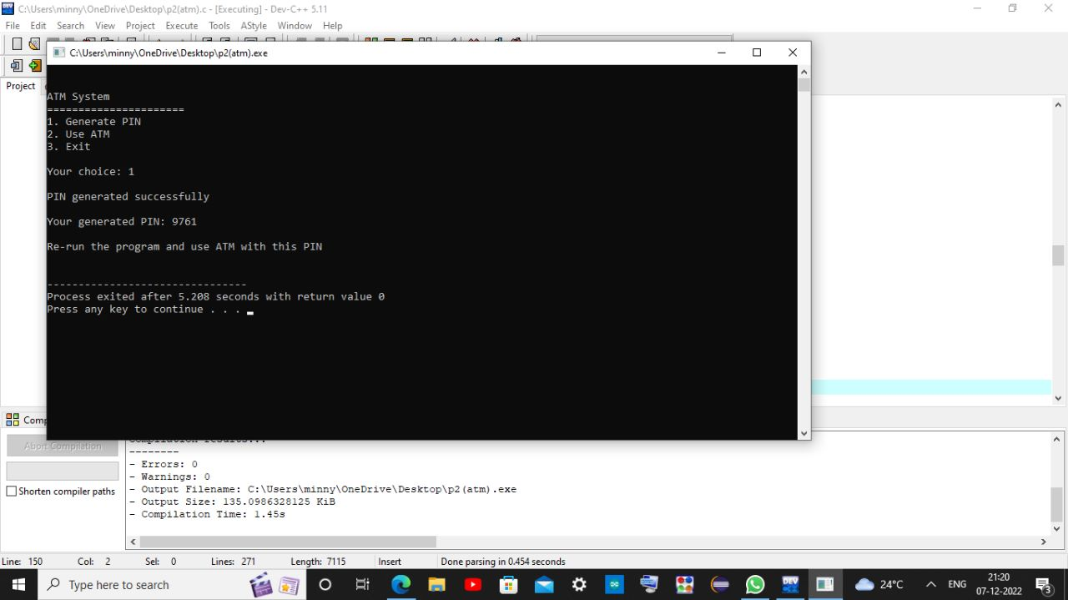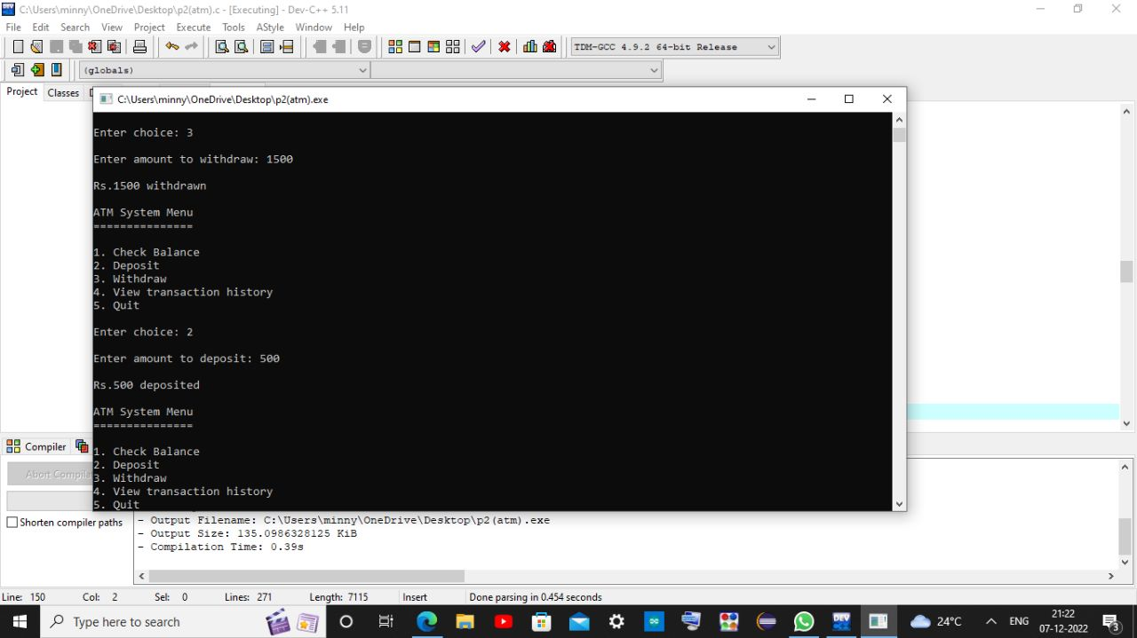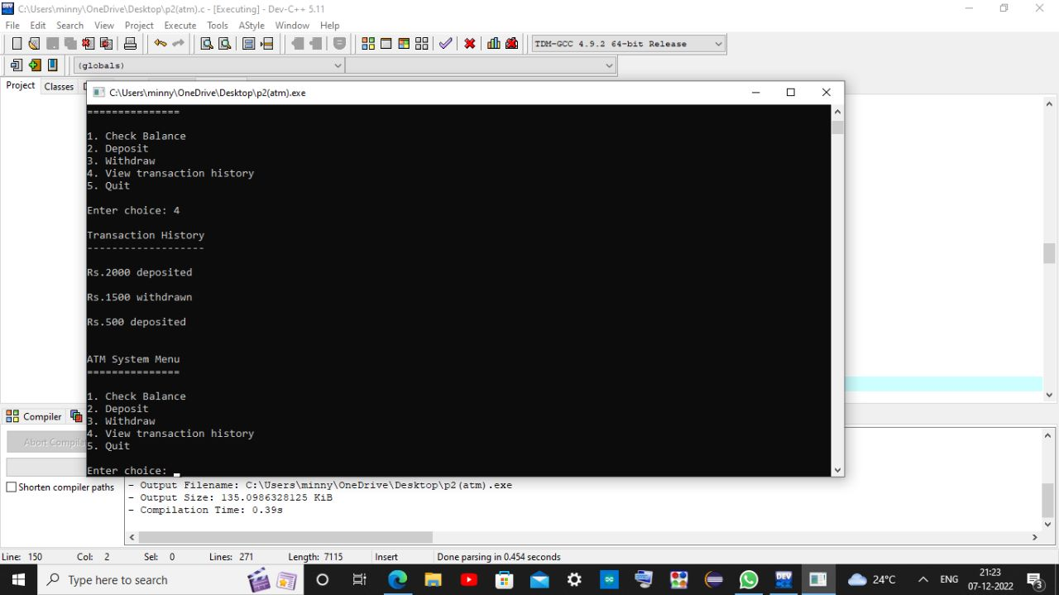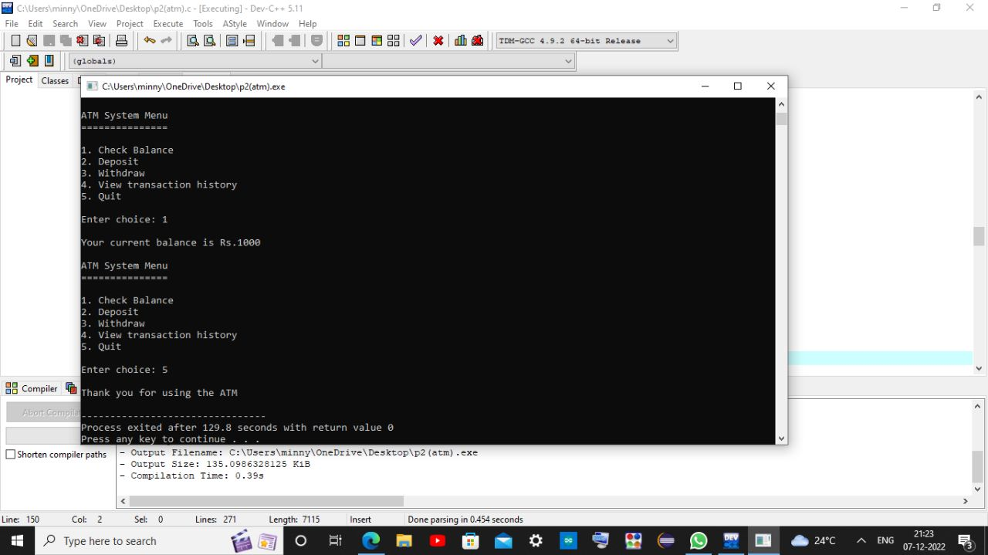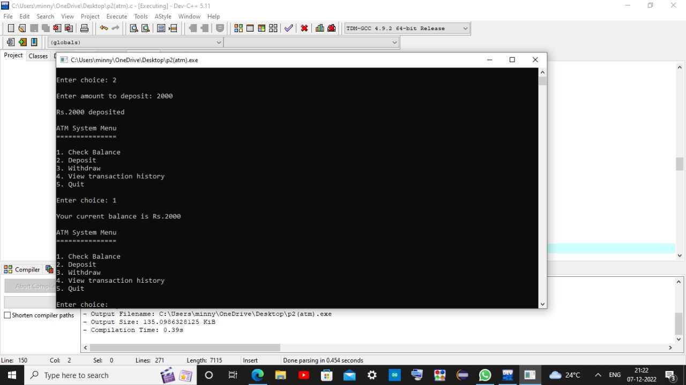

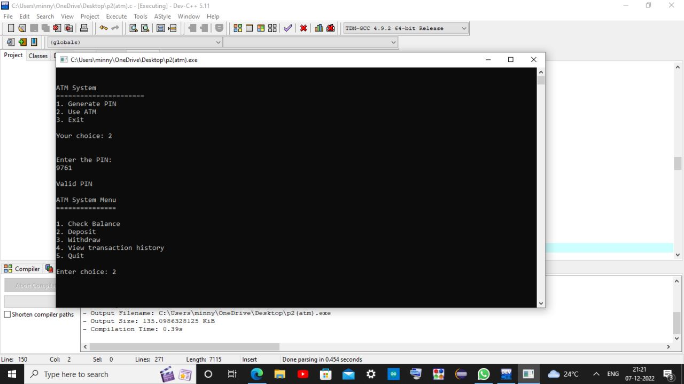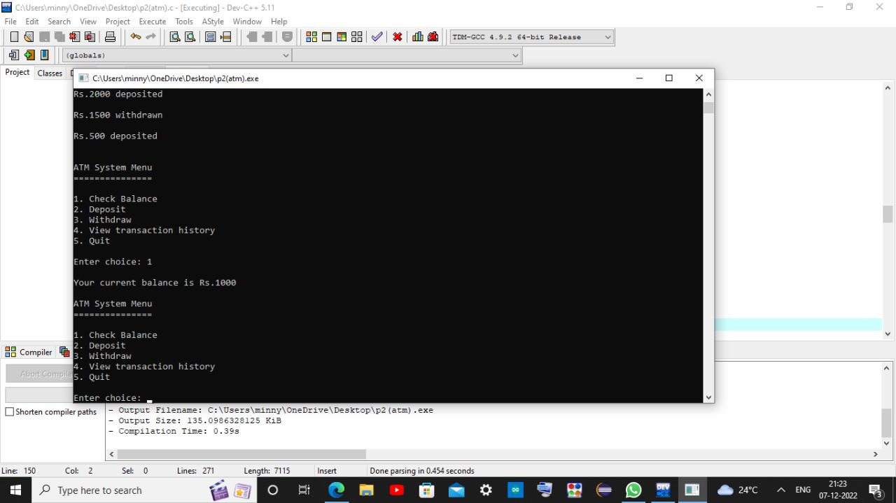

4.CONCLUSION:
This paper develops a model of ATM fees that captures the salient features of the Australian ATM market. In particular, various ATM usage costs, often ignored in the literature, are explicitly incorporated into existing models and the number of banks modelled is increased to three from the usual two. These contributions are important for a number of reasons. First, including ATM usage costs in the model provides the complexity required to understand why, despite claims by the industry that maintaining foreign fees was required to cover own-bank processing costs, foreign fees have mostly been eliminated since the 2009 ATM reforms. Second, having three banks makes the model more realistic and provides a mechanism whereby interchange fee neutrality is maintained but foreign and direct fees no longer need to move in lock-step with changes in the interchange fee, matching the Australian experience.
The consumer response to ATM reform in Australia is a key feature of the data not explained by the model in this or any other paper on ATM fees. However, this paper demonstrates that in the presence of incomplete information, the shift towards direct charging may have contributed to this change in behaviour, even if the price of foreign transactions remained unchanged. In a similar vein, prompting – in this case, a question asking customers if they wish to cancel their foreign ATM transaction – may also have driven the observed consumer behaviour. Future work to incorporate incomplete information into a model of ATM fees would be a potentially useful.

